Abdullrahman Alghanim

04/23/2025

CIS 3367

Module 14: LAB 11 - Windows Forensics & Logging

Capture the Advanced Audit Policy settings for the Logon/Logoff section.

Terminal or Command Prompt showing successful gpudate

The Computers window with the proper IP address added and checked to  
create an audit log subscription.

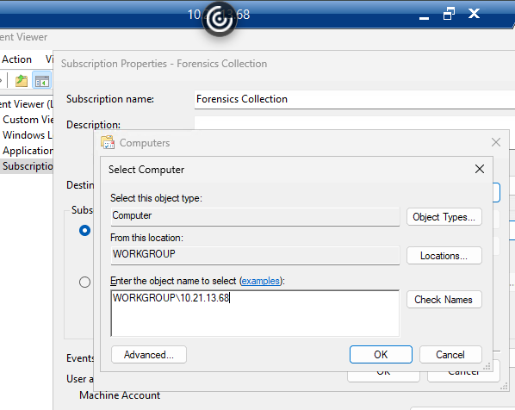

The completed subscription configuration

Terminal output showing successful Sysmon installation.

Windows Event Viewer Sysmon logs.

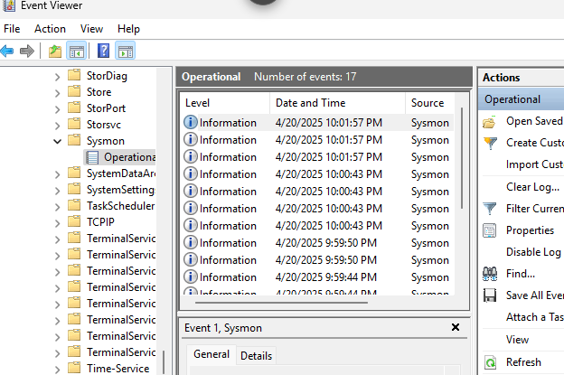

Properties configuration for the System logs with the new settings

